**Project Paper**



**Effects of Lok Sabha Exit Polls**

**On Stock Market**

**Submitted to**

**Dr Azarudheen S (Department Of Statistics)**

*Submitted by a team of students pursuing Bachelor’s Degree in Computer Science, Mathematics and Statistics*

*Shreya Sharma (1740236)*

*Sabarinath V Nair (1740216)*

*Yana Kaveramma (1740266)*

*Gautam Malhotra (1740255)*

*Jeevan Koshy (1740256)*

**SEPTEMBER 2018**

**The impact of Lok Sabha Exit poll results on Indian Stock markets**

**Background:**

The present research aims to study the impact of Lok Sabha Exit poll results on Indian Stock markets via big data analytics. Big data analytics is basically the process of examining large and varied data sets to uncover hidden patterns, market trends, customer preferences and other useful information that can help organizations make more-informed business decisions.

The two big stock exchanges in the country are the Bombay Stock Exchange and the National Stock Exchange. BSE is Asia's first stock exchange. The Bombay Stock Exchange is located at Mumbai and it was established in 1875. The National Stock Exchange or NSE of India is also located in Mumbai. It was established in the year 1992. The BSE and NSE have a set of objectives that include providing liquidity to securities, mobilising savings for our economic development and protecting the interest of investors.

Politics play a major role when it comes influencing the minds of the investors. Especially during the elections a lot of variations are observed in the stock market. Few political parties are biased towards a certain companies and this provokes the investors to invest in the stock market just after the exit poll results which would in turn help them earn large sum of profits.

Through this research paper, the major link between the results of the exit polls and the minds of the investors can be brought out.

**Objectives:**

The objective is to show how does Lok Sabha (election years-1996, 1998, 1999, 2004, 2009, and 2014) exit polls play a major role in affecting the stock market. Further our aim is to perform the following tasks:

1. To study the changes in the indices. (measurement of a section of the stock market)
2. Reaction of the investors and how it can play a major role in formation the government.
3. The variation in the prices once the results are declared.

**Rationale:**

This research paper finding could play a major role in companies and help them to invest in the stock market. Indian stock market is regarded on parity with the developed market as so many developments have taken place in the stock market arena during the last decade. Stock Market is a platform for trading various securities and derivatives without any barriers. In Stock Market various companies are listed to their business venture through public issues. Indian market has started becoming informational more efficient compared to developed countries. The study would facilitate the reader to understand the past, current and future aspects of Indian Stock Market also on how the political parties have or will be affecting the stock markets and how it would earn those profits.

**Research Questions:**

1. Do the exit poll results affect the companies in an industry and is it important from the company’s point of view to look into the exit poll results before making an investment in the stock market?
2. Is it right from the media’s point to conduct a survey just after the elections as they bring variations in the Indian economy?
3. Should exit poll analysis be actually carried out in the country?

**Methodology:**

The research article aims to focus on the companies which were progressing and spreading their business in different industries. Moreover, all these companies from the year 1996 to 2014 have used and form the index of NIFTY. The NIFTY 50 index is National Stock Exchange of India’s benchmark broad based stock market index for the Indian equity market. It represents the weighted average of 50 Indian company stocks in 12 sectors and is one of the main stock indices used in India. Thus any change in their stock price, affects the index as well. The secondary data regarding the companies would be considered to carry out research. This study involves the quantitative analysis methods of comparing the exit poll results of the elections which happened in the past years and how it is been effective to the investors in earning profits for a period of time. In order to get a fair idea on how the results of exit polls bring out the probability of change or continuation of same government in the country, later changed the investors’ perception towards the government and how it affected the stock market.

The data sets that we have taken can be accessed by the link that is mentioned below: <https://docs.google.com/spreadsheets/d/1bbHvoxvHj5CeqREIe22fBq9A9kC2Esc7mhGoDIgIX8s/edit?ts=5b3a3385#gid=1206613289>

**Analysis:**

**1]** The first hypothesis that we are considering is:

H0 = The exit poll results do not affect the stock prices.

H1 = The exit poll results affect the stock prices.

For the testing of the hypothesis we have used the technique of correlation analysis using excel. For this we have taken the turnover of the shares traded of 4 companies. In the data which we have considered, after the exit poll results were out and before the declaration of election results are taken. The exit poll results (1996 - 2014) of the heading political parties to carry out correlation analysis between the exit poll results and total stock market turnover of the companies. For analysis we have used excel software. The following is the result that we obtained after performing the test.

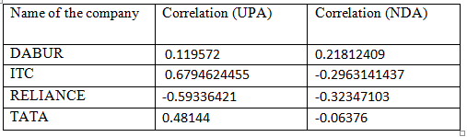

*\*\** ***UPA****- Stands for United Progressive Alliance and led by Congress party, in the UPA**there are many so called secular parties.*

***NDA -*** *The National Democratic Alliance (****NDA****) is a centre-right political alliance led by the Bharatiya Janata Party (BJP)*

From the above correlation analysis that we have performed for the previous years of lok sabha elections, we can come to the following observations for the data we have chosen:

i) Dabur shows a low positive correlation and ITC shows moderately positive correlation with the exit poll results of the UPA alliance. From this we can see that the two leading companies from the health care sector could be benefited when UPA government comes into power.

ii) In the case of the NDA alliance, we can see that Dabur shows low positive correlation whereas ITC shows a low negative correlation with the exit poll results.

iii) Reliance shows a moderately negative correlation with the exit poll results of UPA alliance whereas it shows low negative correlation with the exit poll results.

iv) Tata shows low positive correlation with the exit polls of UPA government whereas shows low negative correlation with the NDA alliance.

**Conclusion:**

From the above observations we can conclude that the prices of  the stock market are affected by the exit poll results of the lok sabha elections. Though there are many other factors which parallely affect the stock prices, yet the impact of exit poll results cannot be neglected as these results decide which alliance would come into power and this in turn affects the trends of the stock market. All this together change the investor’s and the trader’s preferences.

**2]** The second hypothesis which we are considering is :

H0 = There is no significant difference between the turnover of the shares traded before and after the elections.

H1 = There is no significant difference between the turnover of the shares traded before and after the elections.

Secondly, we have considered the paired samples of the total turnover of particular companies in the stock market before and after the elections results were out. Here the volume i.e the turnover of each companies are taken into consideration as it satisfies the three conditions of the paired sample test which are - the sample sizes are equal, they are correlated and the sample size is less than 30. The paired sample test was carried out on SPSS to derive at the conclusions.

The following are the results of the 2 tailed paired sample t- test. We have chosen a sample of 21 days just before the elections began and after the results were out :

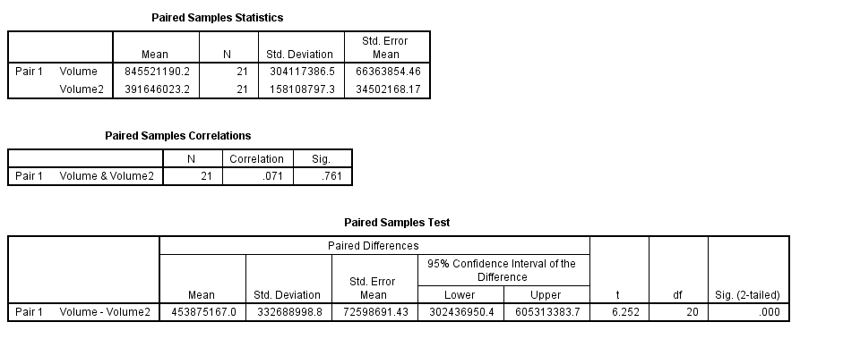**TATA**

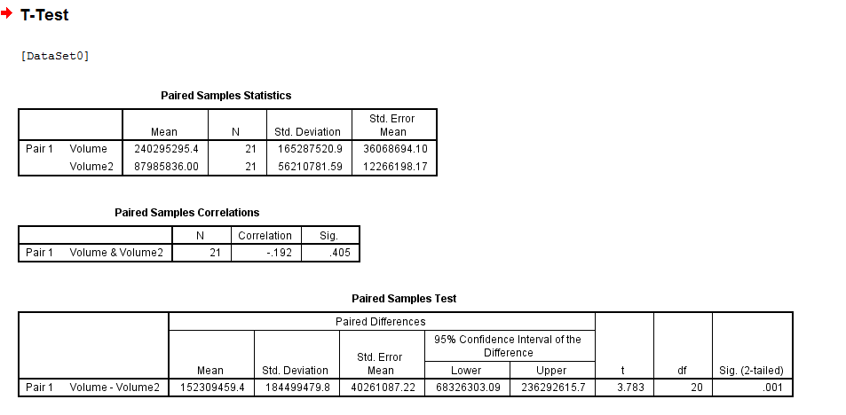**RELIANCE**

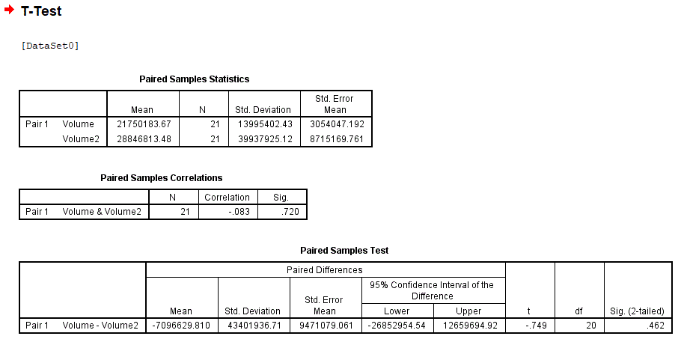**DABUR**

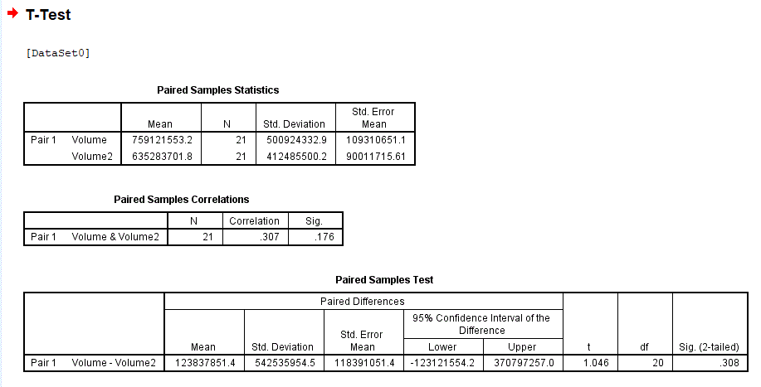**ITC**

*\*\* If the significant value is less then the alpha value i.e. 0.05, then the NULL hypothesis is rejected, otherwise accepted.*

Following is the observations that can be made:

* In case of the dataset for TATA and RELIANCE we reject the NULL hypothesis.
* Whereas, In case of the dataset for ITC and DABUR the NULL hypothesis is accepted.

**Conclusion:**

From the above datasets we have considered and thus we can come to the conclusion that the election results also affect the stock prices. Not all companies are affected by the election results, within a small span of time. Only those companies which are either highly supported or neglected by the ruling party are affected most by the election results.

In the above study, data of the year 1999 is taken in which congress again came into power just after 11 months rule of BJP. Based on our study, TATA and RELIANCE were the front players in the market and as their policies might have changed which would have affected these industries and changed the traders and investor’s perspective.

For the rest of the companies also politics play a major role in setting the trends for their stock but the changes are visible after some times, as it depends upon the policies those changes in the set by the ruling alliance. Whenever there is a change in the rule, major changes in stock prices and volume traded are witnessed.

**REFERENCES:**

* <https://www.firstpost.com/politics/exit-polls-2014-live-ndtv-hansa-gives-nda-279-seats-upa-103-1519525.html>
* <https://www.indiatoday.in/magazine/cover-story/story/19910715-exit-poll-rajiv-gandhi-assassination-resulted-in-distinct-swing-in-favour-of-congressi-814550-1991-07-15>
* <https://www.indiatoday.in/elections/highlights/story/india-tv-c-voter-survey-bjp-nda-alliance-lok-sabha-elections-2014-opinion-polls-192695-2014-05-13>
* <http://election.rediff.com/report/2009/may/16/loksabhapoll-exit-polls-get-it-correct-this-time.htm>
* [www.investopedia.com](http://www.investopedia.com)
* [www.marketonmobile.com](http://www.marketonmobile.com)
* <https://in.finance.yahoo.com/>
* <https://www.bseindia.com/>